1) /* C program for Merge Sort */

#include <stdio.h>

#include <stdlib.h>

void merge(int arr[], int l, int m, int r)

{

int i, j, k;

int n1 = m - l + 1;

int n2 = r - m;

int L[n1], R[n2];

for (i = 0; i < n1; i++)

L[i] = arr[l + i];

for (j = 0; j < n2; j++)

R[j] = arr[m + 1 + j];

i = 0; // Initial index of first subarray

j = 0; // Initial index of second subarray

k = l; // Initial index of merged subarray

while (i < n1 && j < n2) {

if (L[i] <= R[j]) {

arr[k] = L[i];

i++;

}

else {

arr[k] = R[j];

j++;

}

k++;

}

while (i < n1) {

arr[k] = L[i];

i++;

k++;

}

while (j < n2) {

arr[k] = R[j];

j++;

k++;

}

}

void mergeSort(int arr[], int l, int r)

{

if (l < r) {

int m = l + (r - l) / 2;

mergeSort(arr, l, m);

mergeSort(arr, m + 1, r);

merge(arr, l, m, r);

}

}

void printArray(int A[], int size)

{

int i;

for (i = 0; i < size; i++)

printf("%d ", A[i]);

printf("\n");

}

int main()

{

int arr[] = {40,42,44,43,46,41,47,45};

int arr_size = sizeof(arr) / sizeof(arr[0]);

printf("Given array is \n");

printArray(arr, arr_size);

mergeSort(arr, 0, arr_size - 1);

printf("\nSorted array is \n");

printArray(arr, arr_size);

return 0;

}

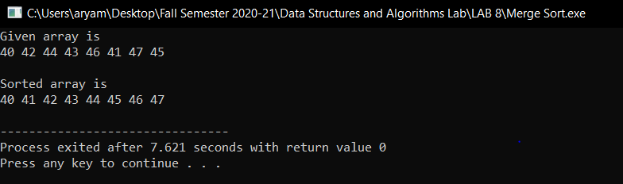

2)

/* C implementation QuickSort */

#include<stdio.h>

void swap(int* a, int* b)

{

int t = *a;

*a = *b;

*b = t;

}

int partition (int arr[], int low, int high)

{

int pivot = arr[high]; // pivot

int i = (low - 1);

for (int j = low; j <= high- 1; j++)

{

if (arr[j] < pivot)

{

i++; swap(&arr[i], &arr[j]);

}

}

swap(&arr[i + 1], &arr[high]);

return (i + 1);

}

void quickSort(int arr[], int low, int high)

{

if (low < high)

{

int pi = partition(arr, low, high);

quickSort(arr, low, pi - 1);

quickSort(arr, pi + 1, high);

}

}

void printArray(int arr[], int size)

{

int i;

for (i=0; i < size; i++)

printf("%d ", arr[i]);

printf("\n");

}

int main()

{

int arr[] = {40,42,44,43,46,41,47,45};

int n = sizeof(arr)/sizeof(arr[0]);

quickSort(arr, 0, n-1);

printf("Sorted array: \n");

printArray(arr, n);

return 0;

}

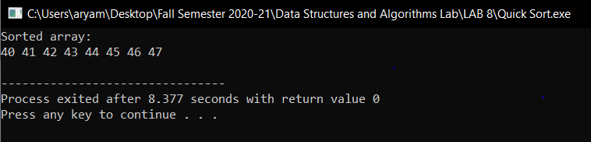

3)// C program to implement recursive Binary Search

#include <stdio.h>

int binarySearch(int arr[], int l, int r, int x)

{

if (r >= l) {

int mid = l + (r - l) / 2;

if (arr[mid] == x)

return mid;

if (arr[mid] > x)

return binarySearch(arr, l, mid - 1, x);

return binarySearch(arr, mid + 1, r, x);

}

return -1;

}

int main(void)

{

int arr[] = {40,42,44,43,46,41,47,45};

int n = sizeof(arr) / sizeof(arr[0]);

int x;

printf("Enter number to be found.\n");

scanf("%d",&x);

int result = binarySearch(arr, 0, n - 1, x);

if(result == -1)

{

printf("Element is not present in array") ;

}

else

{

printf("Element is present at index %d",result);

}

return 0;

}

